**Practical:1**

Aim : Execute Basic TCP/IP utilities and commands. (eg: ping, ipconfig, tracert, arp, tcpdump, whois, host, netsat, nslookup, ftp, telnet etc... )

* **Ping**

The **ping command** helps to verify IP-level connectivity. When troubleshooting, you can **use ping** to send an ICMP echo request to a target host name or IP address. **Use ping** whenever you need to verify that a host computer can connect to the TCP/IP network and network resources.

**Ping Command Syntax**

**ping** [**-t**] [**-a**] [**-n** *count*] [**-l** *size*] [**-f**] [**-i** *TTL*] [**-v** *TOS*] [**-r** *count*] [**-s** *count*] [**-w** *timeout*] [**-R**] [**-S** *srcaddr*] [**-p**] [**-4**] [**-6**] *target* [**/?**]

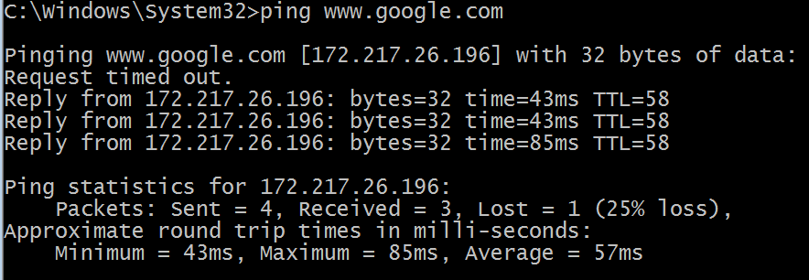

-a : Resolve addresses to hostnames.

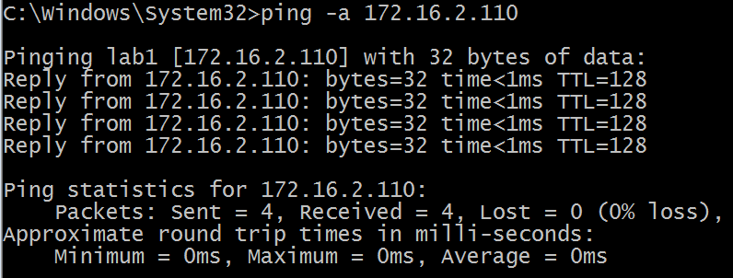

-n count: Number of echo requests to send.



Ipconfig

**Ipconfig**. Displays all current TCP/IP network configuration values and refreshes Dynamic Host Configuration Protocol (DHCP) and Domain Name System (DNS) settings. Used without parameters, **ipconfig** displays the IP address, subnet mask, and default gateway for all adapters.

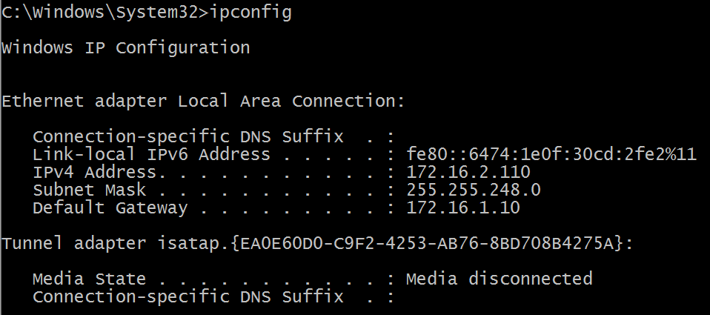

Release: Release the [IPv4](http://www.computerhope.com/jargon/i/ipv4.htm) address for the specified adapter.

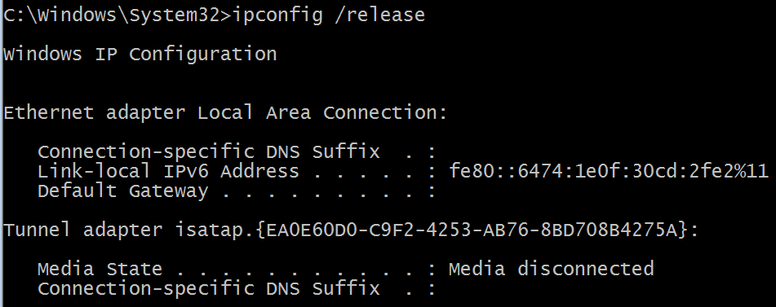

Tracert:

The **tracert command** is a **Command** Prompt **command** that's used to show several details about the path that a packet takes from the computer or device you're on to whatever destination you specify. You might also sometimes see the **tracert command** referred to as the trace route **command** or **traceroute command**.

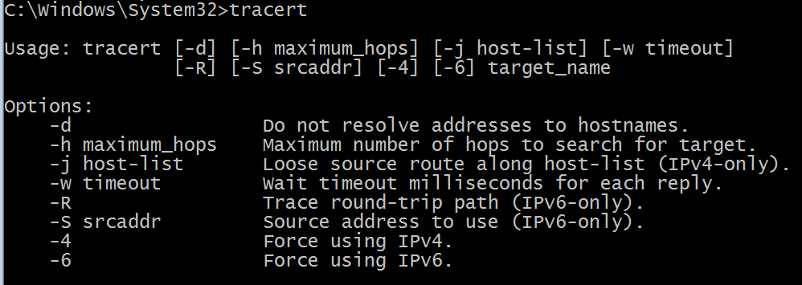

-4: Force using IPv4.

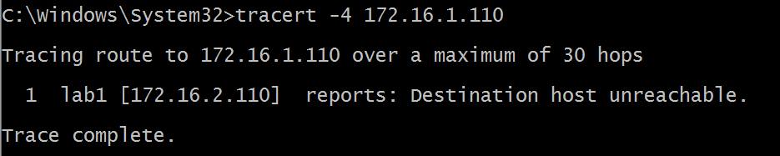

Arp:

An entry for the IP address 192.168.1.1 can be deleted from the **ARP table** using the command "arp -d 192.168.1.1". The next time a packet needs to go to that IP, a new ARP negotiation will be done. If you want to make a specific MAC address be used for an IP, you can use the command: "arp -s 192.168.1.1 [MAC ADDR]".

## Arp syntax

ARP -s inet_addr eth_adr [if_addr]  
ARP -d inet_addr [if_addr]  
ARP -a [inet_addr] [-N if_addr]

-a : Displays current ARP entries by interrogating the current protocol data. If inet_addr is specified, the IP and physical addresses for only the specified computer are displayed. If more than one network interface uses ARP, entries for each ARP table are displayed.

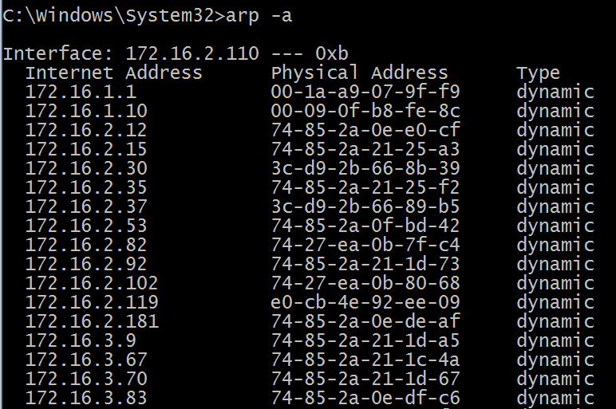

Tcpdump

**tcpdump** is a common **packet** analyzer that runs under the command line. It allows the user to display **TCP**/IP and other packets being transmitted or received over a network to which the computer is attached.

-d: Show the list of available interfaces



Whois:

**whois** searches for an object in a WHOIS database. WHOIS is a [query](http://www.computerhope.com/jargon/q/query.htm) and response protocol that is widely used for querying [databases](http://www.computerhope.com/jargon/d/database.htm) that store the registered users of an [Internet](http://www.computerhope.com/jargon/i/internet.htm) resource, such as a [domain name](http://www.computerhope.com/jargon/d/domain.htm) or an [IP](http://www.computerhope.com/jargon/i/ip.htm) [address](http://www.computerhope.com/jargon/a/address.htm) block, but is also used for a wider range of other information.

-h host: Connect to WHOIS database host *HOST*.

-H: Suppress the display of legal disclaimers.

Host: **host** is a simple utility for performing DNS lookups. It is normally used to convert names to IP addresses and vice versa. When no arguments or options are given, **host** prints a short summary of its command line arguments and options. name is the domain name that is to be looked up.

Netstat

**netstat** (network statistics) is a **command**-line network utility tool that displays network connections for the Transmission Control Protocol (both incoming and outgoing), routing tables, and a number of network interface (network interface controller or software-defined network interface) and network

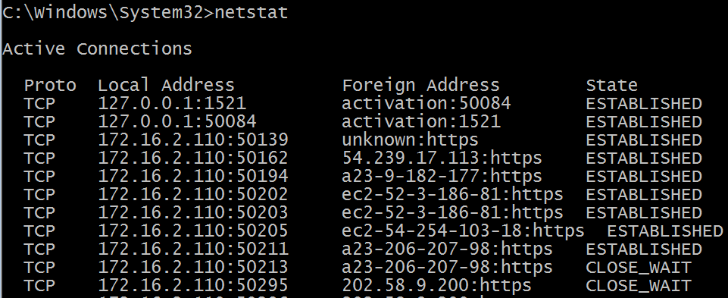-o: A handy option for many troubleshooting tasks, the **-o** switch displays the process identifier (PID) associated with each displayed connection. See the example below for more about using **netstat -o**.

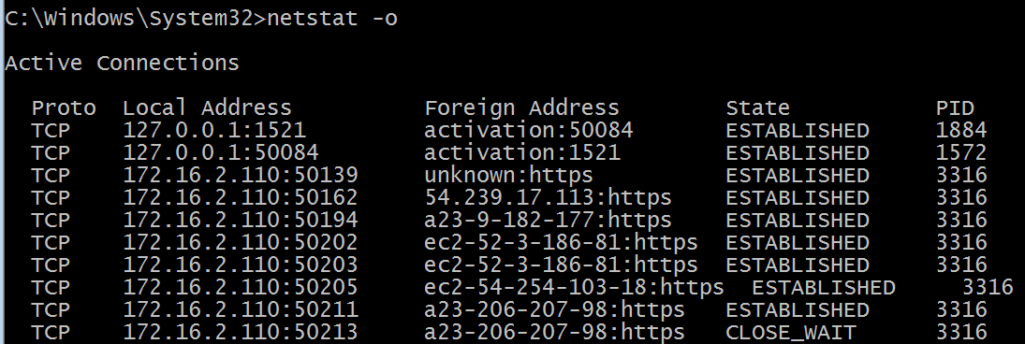nslookup:

**nslookup** is a network administration **command**-line tool available for many computer operating systems for querying the Domain Name System (DNS) to obtain domain name or IP address mapping or for any other specific DNS record.

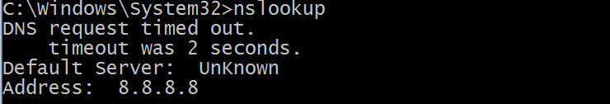

Nslookup –root: Changes the default server to the server for the root of the DNS domain name space.

